**Name – Parag Gattani**

Program No. – 10

Program Title – Gas Sensor

**AIM**

To design a smart gas leakage indicator system.

**HARDWARES REQUIRED**

* Arduino Board
* Gas sensor
* Resistor
* LED
* Breadboard Small

**CIRCUIT DIAGRAM**

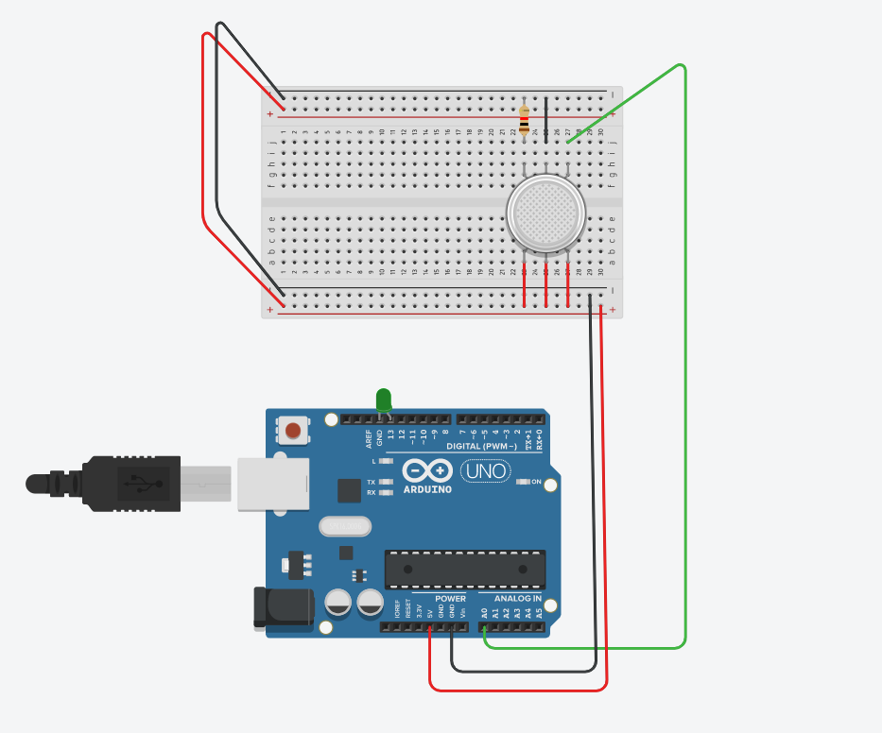

**WRITE-UP**

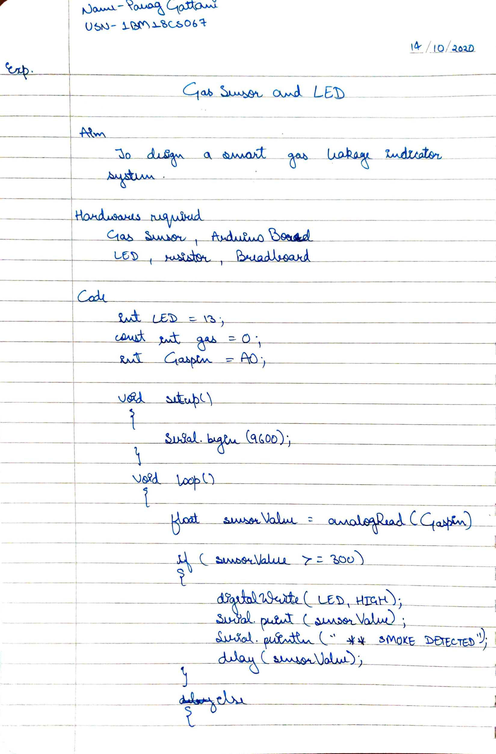



**CODE**

int LED = 13;

const int gas = 0;

int Gaspin = A0;

void setup()

{

Serial.begin(9600);

}

void loop()

{

float sensorValue = analogRead(Gaspin);

if(sensorValue >= 300)

{

digitalWrite(LED, HIGH);

Serial.print(sensorValue);

Serial.println(" *** SMOKE DETECTED ***");

delay(sensorValue);

}

else

{

digitalWrite(LED, LOW);

Serial.println("Serial Value : ");

Serial.println(sensorValue);

}

delay(1000);

}

**OUTPUT**

Designed a smart gas leakage indicator system.